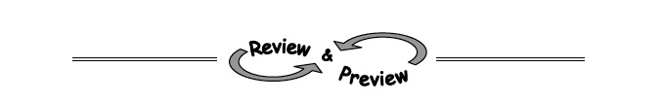
1-14. Evaluate each expression if r = −3, s = 4 , and t = 7.
a. b. $\frac{t-r}{s}$

c. 2s² + r – t d. 3(s − t)²

1-15. Finding and using a pattern is an important problem-solving skill you will use in algebra. The patterns in Diamond Problems will be used later in the course to solve other types of algebraic problems.
Look for a pattern in the first three diamonds below. For the fourth diamond, explain how you could find the missing numbers (?) if you know the two numbers (#).
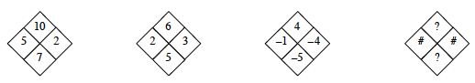
Use the pattern you discovered to complete each of the following diamonds.
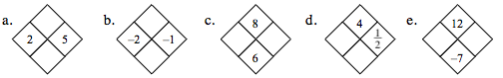

1-16. What value(s) of x will make each equation below true?
a. x + 5 = 5 b. 2x − 6 = 3x + 1 − x − 7

c. 3x + 1= 43 d. 4x − 1 = 4x + 7

A-17. Simplify each algebraic expression below, if possible. If it is not possible to simplify the expression, explain why not. Hints⇔ Help
- 3y + 2y + y² + 5 + y b. 3y² + 2xy + 1 + 3x + y + 2x²
c. 3xy + 5x + 2 + 3y + x + 4 d. 4m + 2mn + m² + m + 3m²
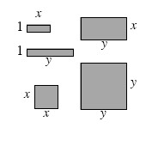
A-21. If the tiles have the dimensions shown below, what is the name of the tile collection below? (That is, what is the total area of all of the pieces?) Write the expression algebraically, using x, x², y, y², and xy.

