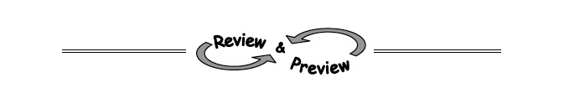
1-3. One focus of this Geometry course is to help you recognize and accurately identify a shape. For example, a rectangle is a four-sided shape with four right angles. Which of the shapes below can be called a rectangle? More than one answer is possible.
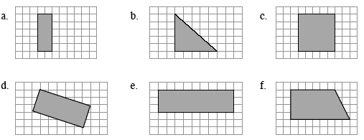
1-4. Calculate the values of the expressions below. Show all steps in your process.
  - 2 · (3(5 + 2) − 1)
  - 6 − 2(4 + 5) + 6
  - 3 · 8 ÷ 2² + 1
  - 5 − 2 · 3 + 6(3² + 1)
1-6. Simplify the expressions below as much as possible.
a. 2a + 4(7 + 5a)
b. 4(3x + 2) − 5(7x + 5)
c. x(x + 5)
d. 2x + x(x + 6)

1-5. Match each table of data with its rule, then briefly explain why it matches the data.
Rules: 1. y = x 2. y = 3x - 1 3. y = x + 3
4. y = x² 5. y = -x² 6. y = x² + 3
x | −1 | 3 | 1 | 0 | −2 | 2
y | −1 | −9 | −1 | 0 | −4 | −4
a. b.
x | 1 | 0 | −4 | 2 | −2 | −1
y | 4 | 3 | −1 | 5 | 1 | 2

x | 3 | −2 | 1 | 0 | 2 | −3
y | 12 | 7 | 4 | 3 | 7 | 12
c. d.

X | −3 | 4 | 2 | −2 | 0 | −10
Y | −10 | 11 | 5 | −7 | −1 | −31

1-7. Examine the graph below. Then, in a sentence or two, suggest reasons why the graph rises at 11:00 AM and then drops at 1:15 PM.
