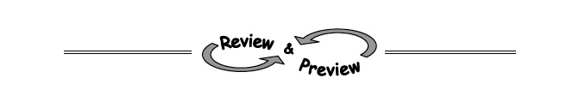

1-4. Angelica is working with function machines. She has the two machines shown at right. She wants to put them in order so that the output of the first machine becomes the input of the second. She wants to use a beginning input of 6.
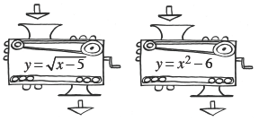

a. In what order must she put the machines to get a final output of 5?

b. Is it possible for her to find an input that will get a final output of –5? If so, show how she could do that. If not, explain why not.

1-5. Evaluate each absolute value expression. Review the Math Notes box in the lesson for the definition of absolute value
a. b. 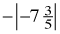 c. d.

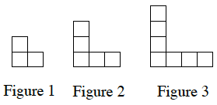
1-6. Examine the tile pattern at right.
a. How does the pattern grow? Explain how you know.

b. How many tiles will there be in Figure 0 (the figure before Figure 1)? Explain how you know.

1-7. Simplify each expression.
 | a. − 42 + (−17) | b. 8 − (−9) | c. 8 (−9)
 | d. − 42 ÷ (− 7) | e. −2 (−3) (−4) | f. −18 – 7
 | g. (−5)² | h. −5² | g.

1-8. For each equation below, find y if x = 2.
a. b. c.

