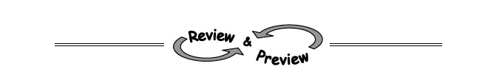
1-78. Which of the relationships below are functions? If a relationship is not a function, give a reason to support your conclusion.
a.
x | y
−3 | 19
5 | 19
19 | 0
0 | −3
b.

x | 7 | −2 | 0 | 7 | 4
y | 10 | 0 | 10 | 3 | 0

c. 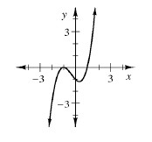 d. 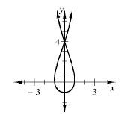

1-79. Find the x- and y-intercepts for the graphs of the relationships in problem 1-78.

1-80. Find the inputs for the following functions with the given outputs. If there is no possible input for the given output, explain why not.
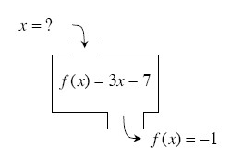
a. b.
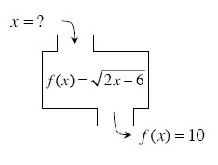

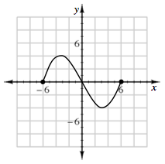
1-81. Use the relationship graphed at right to answer the questions below.

- Is the relation a function?

- What is the domain?

- What is the range?

1-82. What value(s) of x will make each equation true?
- b. c.

