Unit 9 Day 4 Homework 11-36, 11-52, 11-56, 11-57

Pyramid Vocabulary
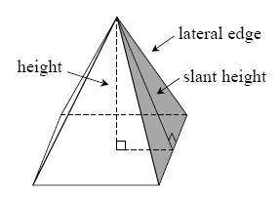
If a face of a pyramid (defined in problem 11-20) or prism is not a base, it is called a lateral face.
The lateral surface area of a pyramid or prism is the sum of the areas of all faces of the pyramid or prism, not including the base(s). The area of the exterior of the TransAmerica building that needs cleaning (from problem 11-21) is an example of lateral surface area, since the exterior of the base of the pyramid cannot be cleaned.
The total surface area of a pyramid or prism is the sum of the areas of all faces, including the bases.
Sometimes saying the word “height” for a pyramid can be confusing, since it could refer to the height of one of the triangular faces or it could refer to the overall height of the pyramid. Therefore, we call the height of each lateral face a slant height to distinguish it from the height of the pyramid itself. See the diagram above.

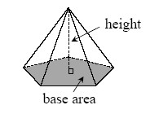
Volume of a Pyramid
In general, the volume of a pyramid is one-third of the volume of the prism with the same base area and height. Thus:
V = (base area)(height)

11-36. Find the volume and surface area of a square-based pyramid if the base edge has length 6 units and the height of the pyramid is 4 units. Assume the diagram below is not to scale.
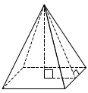

11-52. Find the volume and total surface area of each solid below. Show all work.
- 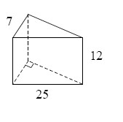 b.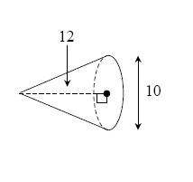

11-56. Examine the diagram below. State the relationship between each pair of angles listed below (such as “vertical angles”) and state whether the angles are congruent, supplementary, or neither.
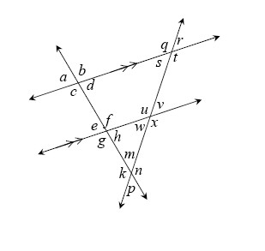
  - e and a
  - t and u
  - v and x
  - g and v

11-57. Multiple Choice: In the diagram below, the value of y is:
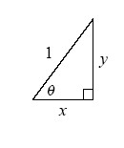
a. sinθ | b. cosθ | c. tanθ | d. x | d.None of these

