Unit 9 Day 6 Homework 11-64, 11-66, 11-74, 11-79

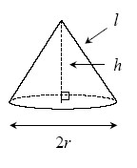
Volume and Lateral Surface of a Cone
Finding the volume of a cone (defined in problem 11-48) is very similar to finding the volume of a pyramid. The volume of a cone is one-third of the volume of the cylinder with the same radius and height. Therefore, the volume of a cone can be found using the formula shown below, where r is the radius of the base and h is the height of the cone.
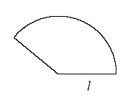
To find the lateral surface area of a cone, imagine unrolling the lateral surface of the cone to create a sector. The radius of the sector would be the slant height, l, of the cone, and the arc length would be the circumference of the base of the cone, .
Therefore, the area of the sector (the lateral surface area of the cone) is:

11-64. As Shannon peeled her orange for lunch, she realized that it was very close to being a sphere. If her orange has a diameter of 8 centimeters, what is its approximate surface area (the area of the orange peel)? What is the approximate volume of the orange? Show all work.

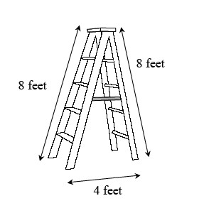
11-66. Hokiri’s ladder has two legs that are each 8 feet long. When the ladder is opened safely and locked for use, the legs are 4 feet apart on the ground. What is the angle that is formed at the top of the ladder where the legs meet?

11-74. The moon is an average distance of 238,900 miles away from the Earth. While that seems very far, how far is it?
- Compare that distance with the circumference of the Earth’s equator. Assume that the Earth’s radius is 4000 miles. How many times greater than the Earth’s circumference is the distance to the moon?

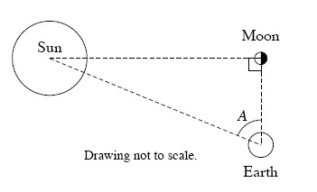
- One way to estimate the distance between the Earth and the sun is to consider the triangle formed by the sun, Earth, and moon when the moon appears to be half-full. (See the diagram at right.) When the moon appears from earth to be half-full, it can be assumed that the moon forms a 90° angle with the sun and the Earth. Using special equipment, Ray found the measure of angle A to be 89.85°. If the moon is 238,900 miles away from the Earth, then how far is the sun from the Earth?

11-79. Multiple Choice: The volume of a solid is V. If the solid is enlarged proportionally so that the perimeter increases by a factor of 9, what is the volume of the enlarged solid?
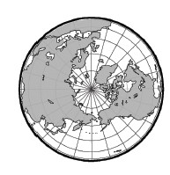
a. 9V | b. $\frac{81}{4}V$ | c. 81V | d. 729V

