Unit 9 Day 5 Homework 11-8, 11-9, 11-12, 11-17
11-8. Draw a hexagon on your paper.

  - Do all hexagons have an interior angle sum of 720°?

  - Does every hexagon have an interior angle measuring 120°? Explain your reasoning.

  - Does every hexagon have 6 sides? Explain your reasoning.

11-9. The lateral surface of a cylinder is the surface connecting the bases. For example, the label from a soup can could represent the lateral surface of a cylindrical can. If the radius of a cylinder is 4 cm and the height is 15 cm, find the lateral surface area of the cylinder. Note: It may help you to think of “unrolling” a soup can label and finding the area of the label.

11-12. Three flags are shown below on flagpoles. For each flag, determine what shape appears if the flag is spun very quickly about its pole. If you do not know the name of the shape, describe it.
- 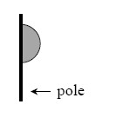
- 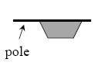
- 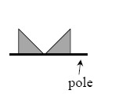

11-17. Examine the diagram of the triangle at right. 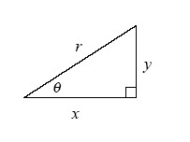
- Write an equation representing the relationship between x, y, and r.

- Write an expression for sinθ. What is sinθ if r = 1?

- Write an expression for cosθ. What is cosθ if r = 1?

