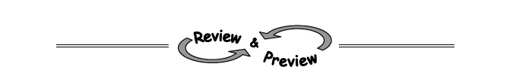
2-19. What shape will the graph of y = x² + 2 be? How can you tell? Justify your prediction by making a table and graphing y = x² + 2 on graph paper.

2-20. Evaluate each expression for x = −2 and y = −5.
  - 1 − 2x + 3y b.

c. 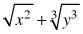 d.

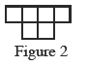
2-22. Figure 2 of a tile pattern is shown at right. If the pattern grows linearly and if Figure 5 has 15 tiles, then find a rule for the pattern.

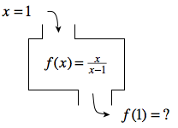
2-23. Find the output for the relation with the given input. If there is no possible output for the given input, explain why not.

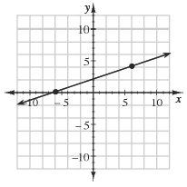
2-24. Find the slope of the line shown on the graph below.

