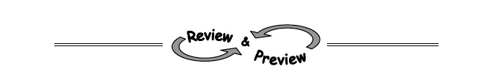
2-31. Does the table below appear to represent a function? If so, write an equation using function notation that represents the table. If not, explain why it cannot represent a function.
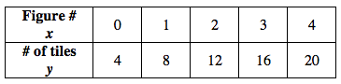

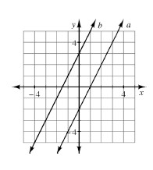
2-32. When Yoshi graphed the lines y = 2x + 3 and y = 2x − 2, she got the graph shown at right.
  - One of the lines at right matches the equation
y = 2x + 3, and the other matches y = 2x − 2. Which line matches which equation?

  - Yoshi wants to add the line y = 2x + 1 to her graph. Predict where it would lie and sketch a graph to show its position. Justify your prediction.

  - Where would the line y = −2x + 1 lie? Again, justify your prediction and add the graph of this line to your graph from part (b).

2-33. On graph paper, graph a line with y-intercept (0, −4) and x-intercept (3, 0). Find the equation of the line.
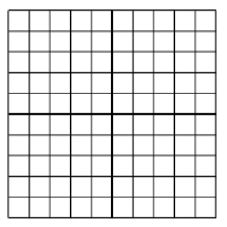

2-34. Draw Figures 1, 2, and 3 for a tile pattern that could be described by y = −3x + 10.

2-35. What number is not part of the domain of ? How can you tell?

