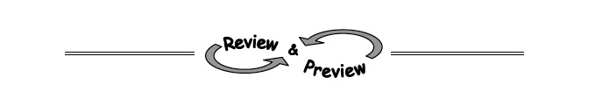
2-41. If :
  - What is the slope of the line?

  - What is the y-intercept of the line?

  - Graph the line.
2-42. Without graphing, find the slope of each line described below
- A line that goes through the points (4, 1) and (2, 5).

- A line that goes through the origin and the point (10, 5).

- A vertical line (one that travels “up and down”) that goes through the point (6, −5).

- A line that goes through the points (1, 6) and (10, 6).

2-43. Ms. Cai’s class is studying a tile pattern. The rule for the tile pattern is
y = 10x − 18. Kalil thinks that Figure 12 of this pattern will have 108 tiles. Is he correct? Justify your answer.

2-44. State the slope and y-intercept of each line.
Slope y-intercept

2-45. Evaluate the expressions below for the given values.
a. −x² + 3x for x = −3 b. 5 − (x − 2)² for x = −1

c. d. 