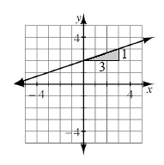
Writing the Equation of a Line from a Graph
One of the ways to write the equation of a line directly from a graph is to find the slope of the line (m) and the y-intercept (b). These values can then be substituted into the general slope-intercept form of a line: y = mx + b.
For example, the slope of the line at right is m = , while the y-intercept is (0, 2). By substituting m = and b = 2 into y = mx + b, the equation of the line is:
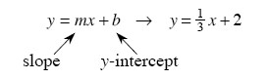
2-59. Consider the following tile pattern.
a. Create an Input/Output table for the tile pattern.

b. Write the equation for the tile pattern.

2-50. Solve each of the following equations.
a. 1.5w + 3 = 3 + 2w b. 6x − 21 = 5x + 17 + x

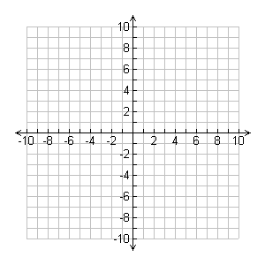
2-64. Graph each of the following equations
on the same set of axes.
  - y = 3x + 5
  - y = −2x + 10

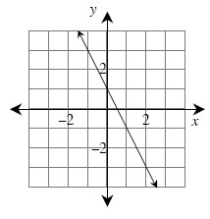
2-65. Review what you know about graphs by answering the following questions.
- Find the equation of the line graphed at right.
- What are its x- and y-intercepts?

