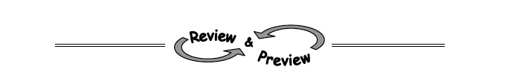
2-6. A tile pattern has 5 tiles in Figure 0 and adds 7 tiles in each new figure. Make a table that shows this pattern. Write the equation of the line that represents the growth of this pattern.

2-7. Evaluate each expression if r = −3, s = 4, and t = −7.
  - b.

c. d.

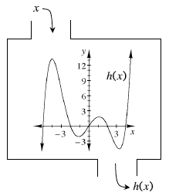
2-8. Examine the relation h(x) defined at right. Then estimate the values below.
  - h(1)
  - h(3)
  - x when h(x) = 0
  - h(−1)
  - h(−4)

2-9. Which of the relations below are functions? Justify your answer.
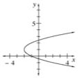
a. b. c.
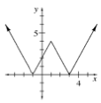
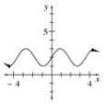

For each graph above, state the domain and range.
Graph a. Domain: Range:

Graph b. Domain: Range:

Graph c. Domain: Range

2-10. Examine the graphs in problem 2-9 again. Which, if any, have lines of symmetry? Draw in any lines of symmetry.

