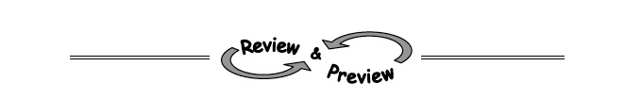
- 2-70. Sometimes the quickest and easiest two points to use to graph a line that is not in slope-intercept form are the x- and y-intercepts. Find the x- and y-intercepts for the two lines below and then use them to graph each line. Write the coordinates of the x- and y-intercepts on your graph. (HINT: Plug x = 0 in to find the y-intercept and plug y = 0 in to find the x-intercept.)
  - x − 2y = 4 b. 3x + 6y = 24

- 2-71. Find the slope of the line passing through each pair of points below.

- (1, 2) and (4, −1)
- (7, 3) and (5, 4)
- (−6, 8) and (−8, 5)
- (55, 67) and (50, 68)

- Goofey got 1 for the slope of the line through points (1, 2) and (4, −1). Explain to her the mistake she made and how to find the slope correctly.

- 2-72. Evaluate the following expressions.
- 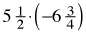
- 2-73. Complete the table below. Then write the corresponding equation.
IN (x) | 2 | 4 | 6 | 7 |  | 10
OUT (y) | −7 | −17 |  |  | −37
- 2-74. MATCH-A-GRAPH
Match the following graphs with their equations. Pay special attention to the scaling of each set of axes. Explain how you found each match.
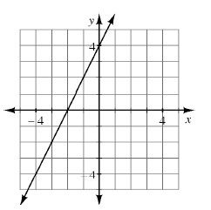  a. y = + 4 | b. y = + 4 | 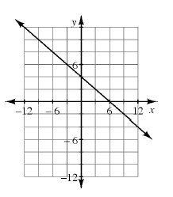  c. y = 2x + 4 | d. y = + 4

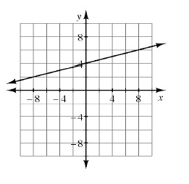
1. 1. 2.

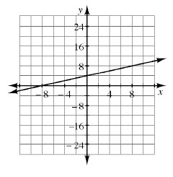

3. 4.

