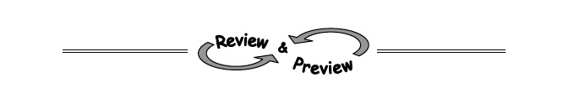

2-82. The point (21, 32) is on a line with slope 1.5.
- Find the equation of the line.

- Find the coordinates of another point on the line.

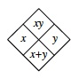2-83. Copy and complete each of the Diamond Problems below. The pattern used in the Diamond Problems is shown at right.
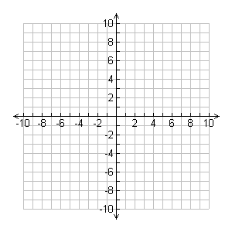
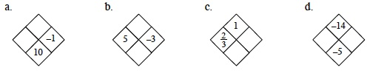

2-84. The graph of the equation 2x − 3y = 7 is a line.
- Find the x- and y-intercepts and graph the line using these two points.
- If a point on this line has an
x-coordinate of 10, what is its
y-coordinate?
2-85. Without graphing, identify the slope and y-intercept of each equation below.
- y = 3x + 5
- y =
- y = 3
- y = 7 + 4x
2-86. Graph the line .

