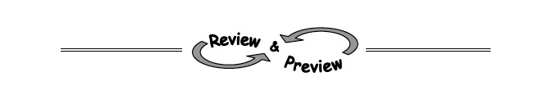
3-19. Which of the expressions below are equivalent to 16x⁸? Make sure you find all the correct answers!
  - (16x⁴)²

  - 8x² · 2x⁶

  - (2x²)⁴

  - (4x⁴)²

3-20. Rewrite each expression below without negative or zero exponents.
- 4⁻¹

- 7⁰

- 5⁻²

- x⁻²

3-21. Simplify and solve each equation below for x. Record your work.
  - 3x − 7 = 2 b. 1 + 2x − x = x −5 + x

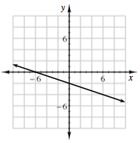
3-22. For the line graphed to the right:
  - Determine the slope.
  - Find the equation of the line.

3-23. Write and solve an equation to represent the given situation. Be sure to define your variable.

Samantha currently has $1500 in the bank and is spending $35 per week. How many weeks will it take until her account is worth only $915?

