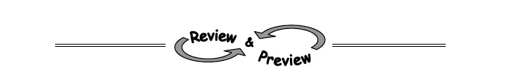
3-24 Complete the table and determine the equation of the line containing the points.
x | −2 | −1 | 0 | 1 | 2 | 3
y | −7 | −4 |  |  | 5 | 8

3-34. Solve each equation. Show the check to prove your answer is correct.
a. 3x + 5 − x = x – 3 b. 5x − (x + 1) = 5 − 2x

3-44. Simplify each expression below, if possible.
- 5x(3x)
- 5x + 3x
- 6x(x)
- 6x + x

3-81. Find each of the following products by drawing and labeling a generic rectangle or by using the Distributive Property.
  - −4y(5x + 8y)
  - 9x(− 4 + 10y)
  - (x² − 2)(x² + 3x + 5)

3-83. Find the dimensions of the generis rectangle below. Then write an equivalency statement (length · width = area) of the area as a product and as a sum.
