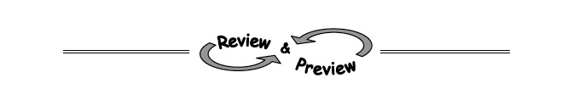
3-38. Find the equation of the line based on the table.
x | 2 | 4 | 6 | 8
y | 2 | 3 | 4 | 5

3-41. Consider the rule y = 2x − 4.
- What is the slope and the y-intercept of y = 2x − 4
- Make a table and graph y = 2x – 4
x | -1 | 0 | 1 | 2 | 3
y

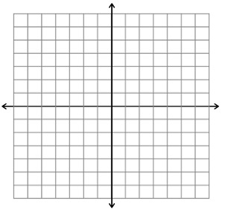

c. How could you find the x-intercept of y = 2x − 4 with your graph? How would you find it with the table? Explain.
3-55. Multiply the algebraic expressions. Use the generic rectangle method or the distributive property method.
a. (x + 3)(2x + 1) | b. 2x(x + 5)
c. (2x + 1)(2x + 1) | d. (2x)(4x)
e. 2(3x + 5) | 5. y(2x + y + 3)

3-98. Simplify each expression using the laws of exponents.
- (x²)(x²y³)

- 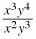

- (2x²)(−3x⁴)

- (2x)³

