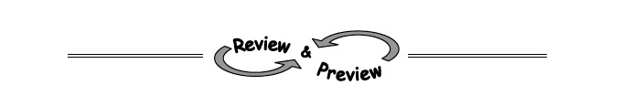
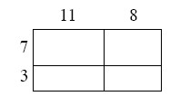
3-48. For the entire rectangle at right, find the area of each part and then find the area of the whole.

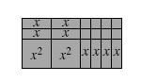
3-49. Write the area of the rectangle at right as a product and as a sum.

3-50. When solving = for x, Nathan noticed that x is divided by 6.
  - What can he do to both sides of the equation to get x alone?

  - Solve for x. Then check your solution in the original equation.
=

  - Use the same process to solve this equation for x: = .

3-51. Girl wants to play a game called “Guess My Line.” She gives you the following hints: “Two points on my line are (1, 1) and (2, 4)."
- What is the slope of her line? A graph of the line may help.

- What is the y-intercept of her line?

- What is the equation of her line?

