3-69. On graph paper, plot ABCD if A(0, 3), B(2, 5), C(6, 3), and D(4, 1).
- Rotate ABCD 90° clockwise () about the origin to form A′B′C′D′. Name the coordinates of B′.
- Translate A′B′C′D′ up 8 units and left 7 units to form A″B″C″D″. Name the coordinates of C″.
- After rotating ABCD 180° to form A′″B′″C′″D′″, Arah noticed that A′″B′″C′″D′″ position and orientation was the same as ABCD. What was the point of rotation? How did you find it?
3-70. Use the relationships in each diagram below to solve for x. Justify your solution by stating which geometry relationships you used.

- 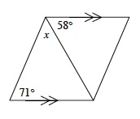
- 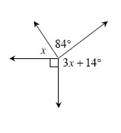
- 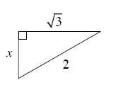

3-72. Explain how you know that the shapes below are similar.
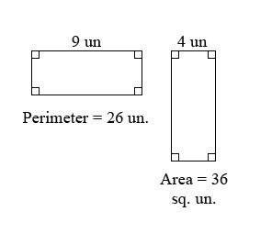
3-89. Determine which similarity conjectures (AA ∼, SSS ∼, or SAS ∼) could be used to establish that the following pairs of triangles are similar. List as many as you can.

- 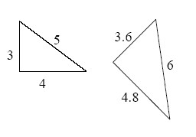
- 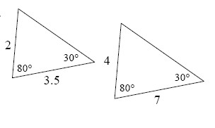
- 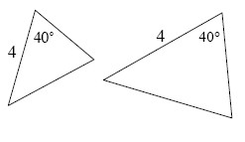

3-91. On graph paper, sketch a rectangle with side lengths of 15 units and 9 units. Shrink the rectangle by a zoom factor of . Make a table showing the area and perimeter of both rectangles.

