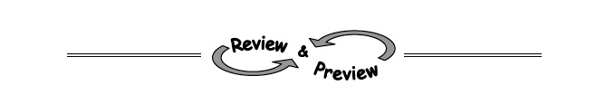
3-6. Use what you have learned about exponents to rewrite each of the expressions below.
  - b. x³ · x⁴

c. (3k ⁵)² d. n⁷ · n

e. 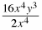 f. 4xy³ · 7x²y³

3-8. Use what you know about slope and y-intercept to graph y = − + 3.
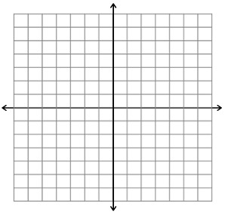

3-9. Write an expression to represent the given situation. Be sure to define your variable.
Sam currently has $150 in a savings account and is saving $10 per week.

3-10. Find f(−3) for each function below.
  - f(x) = −2x +3

