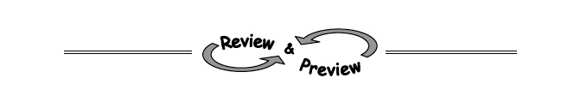
3-70. Use a generic rectangle to multiply the following expressions. Write each solution both as a sum and as a product.
  - (2x + 5)(x + 6)
  - (m − 3)(3m + 5)
  - (12x + 1)(x² − 5)
  - (3 − 5y)(2 + y)

3-71. Find the rule for the pattern represented below.
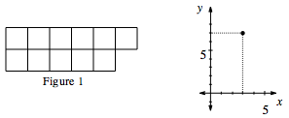
3-72. Harry the Hungry Hippo is munching on the lily pads in his pond. When he arrived at the pond, there were 20 lily pads, but he is eating 4 lily pads an hour. Heinrick the Hungrier Hippo found a better pond with 29 lily pads! He eats 7 lily pads every hour.
  - If Harry and Heinrick start eating at the same time, when will their ponds have the same number of lily pads remaining?
  - How many lily pads will be left in each pond at that time?

3-75. Simplify each of the expressions below. Your final simplification should not contain negative exponents.
- (5x³)(−3x⁻²)

- (4p²q)³

- 