3-71. Solve for the missing lengths in the sets of similar figures below. Show all work.
- ΔGHI ∼ ΔPQR
  - 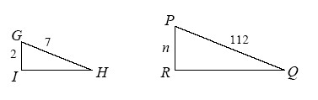
- ΔABC ∼ ΔXYZ
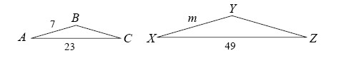
3-80. Determine which of the following pairs of triangles are similar. Explain your work.

- 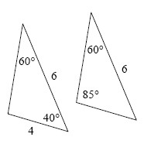
- 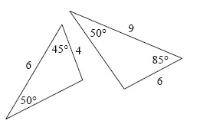
- 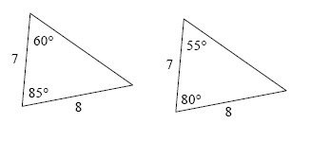

3-81. The dashed line below represents the line of symmetry of the shaded figure. Find the area and perimeter of the shaded region. Show all work.
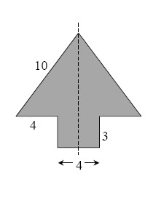
3-82. Examine the diagrams below. For each one, write and solve an equation to find x. Show all work.

- 
 