3-90. Solve each equation to find the value of x. Leave your answers in decimal form accurate to the thousandths place.

- 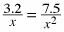
- 4(x − 2) + 3(−x + 4) = −2(x − 3)
- 2x² + 7x − 15 = 0
- 3x² − 2x = −1

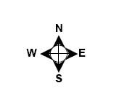
3-92. Susan lives 20 miles northeast of Matt. Simone lives 15 miles dues south of Susan. If Matt lives due west of Simone, approximately how many miles does he live from Simone? Draw a diagram and show all work.

3-96. Use the relationships in the diagram below to solve for x and y. Justify your solutions.
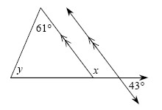
3-97. The area of the triangle below is 25 square units. Find the value of h. Then find the perimeter of the entire triangle. Show all work.
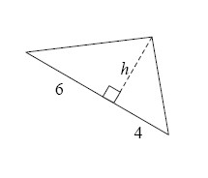

3-100. The area of the rectangle shown below is 40 square units. Write and solve an equation to find x. Then find the dimensions of the rectangle.
