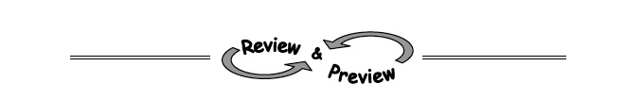
3-94. Solve each equation below for the indicated variable.

- 3x − 2y = 18 for x b. 3x − 2y = 18 for y

c. rt = d for r d. for r

3-96. Find the equation of each line described below.
- A line with slope of 0 that passes through the point (6, –11).

- A line that passes through the points (12, 12) and (20, 6).

3-107. Solve each equation.
  - 3(x − 2) = −6 b. 2(x + 1) + 3 = 3(x − 1)

3-111. Complete these generic rectangles on your paper. Then write the area of each rectangle as a product of
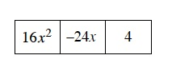
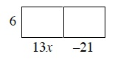

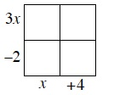
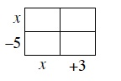

4-10. On the same set of axes, use slope and y-intercept to graph each line in the system shown below. Then find the point(s) of intersection, if one (or more) exists.

