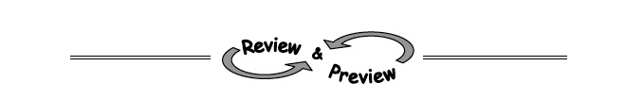

3-97. Make an x,y table for the equations and then graph the lines y = −4x + 3 and y = x − 7 on the same set of axes. Then find their point of intersection.
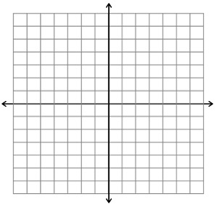
x
x
y
y

3-100. Find each of the following products by drawing and labeling a generic rectangle or by using the Distributive Property.
- 5x(x − 6)
- −9y(6 − 3y)
- (x + 2) (x + 3)
- (x + 1) (x + 5)
3-102. Solve each of the following equations. Be sure to show your work carefully and check your answers.
  - 2(3x − 4) = 22 b. 12x − 30 = −(x + 4)

c. 2 − y − 4 = 3y d. 3 + 4x + 4 = 159

3-108. Complete the table and find the equation of the line (y = Mx + B). Use the slope (M) and the y-intercept (B) as shown in the table.

x | -1 | 0 | 1 | 2 | 3
y | -8 | -5 |  | 1

3-112. Simplify using only positive exponents.

- (3x²y)(5x)
- (4x²y³)(3x⁵y²)
- $\frac{18x^{5}y^{3}}{9x^{7}y}$
- (2x)⁰

