4-16. Use your Trig Table from problem 4-15 to help you find the value of each variable below.

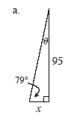

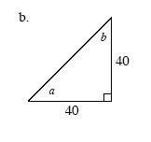
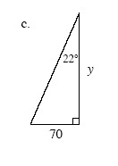

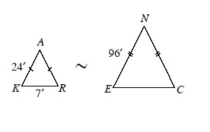
4-17. The triangles shown at the right are similar.
- What is the ratio of side length NE to side length AK?

- Use a ratio to compare the perimeters of ΔENC and ΔKAR. How is the perimeter ratio related to the side length ratio?

- If you have not already done so, find the length of .

4-18. Examine each pair of figures below. Are they similar? Explain how you know.

- 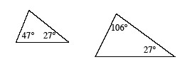

- 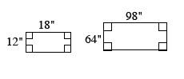
- 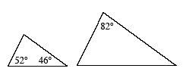

4-19. Find the equation of the line with a slope of that goes through the point (0, 9).

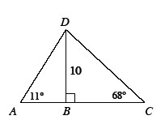
4-20. Examine the figure at the right, which is not drawn to scale. Which is longer, or ? Explain your answer.

