• 4-25. Ben thinks that the slope ratio for this triangle is . Carlissa thinks the ratio is . Who is correct? Explain your thinking fully.

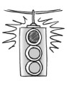
• 4-26. Use your observations from problem 4-24 to answer the following questions:
- Thalia did not have a tool to help her find the slope angle in the triangle below. However, she claims that the slope angle has to be more than 45°. Do you agree with Thalia? Why?
  - 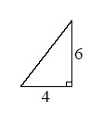
- Lyra was trying to find the slope ratio for the triangle below, and she says the answer is =2.675. Isiah claims that cannot be correct. Who is right? How do you know?
  - 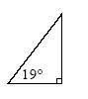

- Without finding the actual value, what information do you know about x in the diagram below?
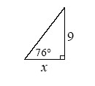

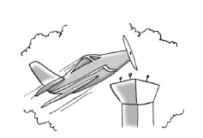
• 4-27. An airplane takes off and climbs at an angle of 11°. If the plane must fly over a 120-foot tower with at least 50 feet of clearance, what is the minimum distance between the point where the plane leaves the ground and the base of the tower?
- Draw and label a diagram for this situation.
- What is the minimum distance between the point where the plane leaves the ground and the tower? Explain completely.
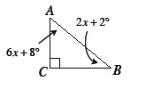
• 4-29. Use what you know about the sum of the angles of a triangle to find m ABC and mBAC. Are these angles acute or obtuse? Find the sum of these two angles. How can we describe the relationship of these two angles?

