• 4-36. Find the missing side length for each triangle. Use the tangent button on your calculator to help.
- 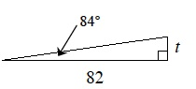
- 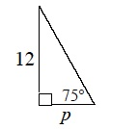
- 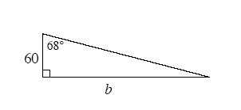
• 4-37. Use the relationships in the diagrams below to write an equation and solve for x.
- 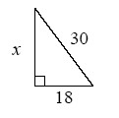
- 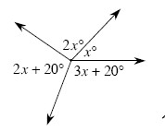
- 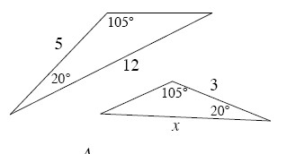
• 4-38.What is the relationship of the triangles below? Justify your conclusion.
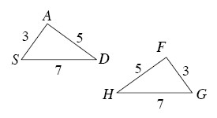
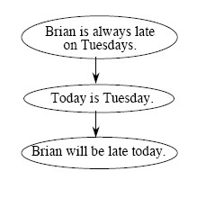
• 4-39. Mr. Singer made the flowchart at the right about a student named Brian.
- What is wrong with Mr. Singer’s flowchart?
- Rearrange the ovals so the flowchart makes more sense.

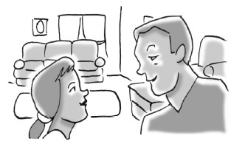
• 4-40. When she was younger, Mary had to look up at a 68° angle to see into her father’s eyes whenever she was standing 15 inches away. How high above the flat ground were her father’s eyes if Mary’s eyes were 32" above the ground?

