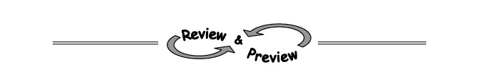
4-61 Jai was solving the system of equations below when something strange happened.
y = −2x + 5
2y + 4x = 8
a. Solve the system algebraically. Explain to Jai what the solution should be.

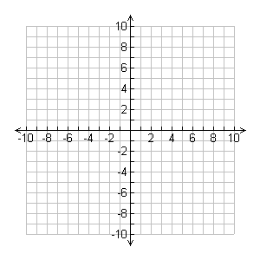

b. Graph the two lines on the same set of axes. What happened?
c. Explain how the graph helps to explain your answer in part (a).

4-102. Mr. Greer solved an equation below. However, when he checked his solution, it did not make the original equation true. Find his error and then find the correct solution.
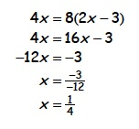

4-104. Thirty coins, all dimes and nickels, are worth $2.60. How many nickels are there?

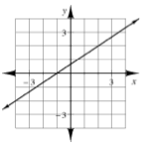
4-105. Multiple Choice: Martha’s equation has the graph shown at right. Which of these are solutions to Martha’s equation? (Remember that more than one answer may be correct.)
(−4, −2)
(−1, 0)
x = 0 and y = 1
x = 2 and y = 2

4-111. Solve the systems of equation using the method of your choice. Check your solutions
3y − 1 = x
4x − 2y = 16

