4-6. Use what you know about the angles of a triangle to find the value of x and the angles in each triangle below.

- 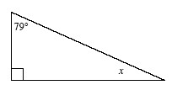

- 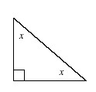
- 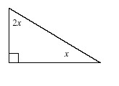

- 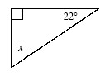

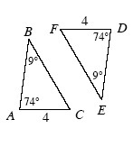
4-7. Use the triangles at the right to answer the following questions.
- Are the triangles at right similar? How do you know? Show your reasoning in a flowchart.

- Examine your work from part (a). Are the triangles also congruent? Explain why or why not.

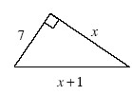
4-8. As Randi started to solve for x in the diagram at right, she wrote the equation 7² + x² = (x + 1)² .
- Is Randi’s equation valid? Explain your thinking.

- To solve her equation, first rewrite (x + 1)² by multiplying (x + 1)(x + 1). You may want to review the Math Notes box for Lesson 2.2.2.

- Now solve your equation for x.

- What is the perimeter of Randi’s triangle?

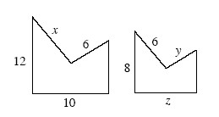
4-9. Assume that the shapes at the right are similar. Find the values of x, y, and z.

4-10. Are the lines represented by the equations below parallel? Support your reasoning with convincing evidence.
