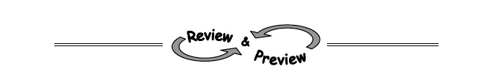
- 4-71. Solve these systems of equations using any method. Check each solution, if possible.
  - 2x + 3y = 9
−3x + 3y = −6
c. y = + 7
y = x − 8

4-72. For each line below, make a table and graph. What do you notice?
  - y = − 1
  - 2x − 3y = 3
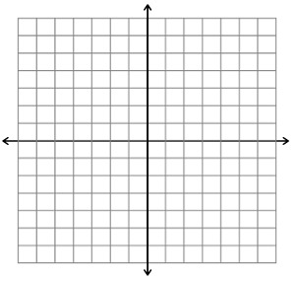

4-73. Find all possible values for x in each equation.

4-74. Aimee thinks the solution to the system below is (−4, −6). Eric thinks the solution is (8, 2). Who is correct? Explain your reasoning.
2x − 3y = 10
6y = 4x − 20

4-75. Figure 3 of a tile pattern has 11 tiles, while Figure 4 has 13 tiles. If the tile pattern grows at a constant rate, how many tiles will Figure 50 have?

4-76. Solve each equation for the indicated variable.
  - y = mx + b (for b)
c. I = prt (for t)

