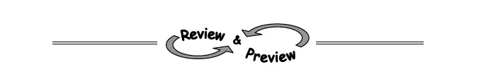
4-81. Solve the following systems of equations using any method. Check each solution, if possible.

  - −2x + 3y = 1
2x + 6y = 2
  - 3x − y = 7
y = 3x − 2

4-82. The Math Club is baking pies for a bake sale. The fruit-pie recipe calls for twice as many peaches as nectarines. If it takes a total of 168 pieces of fruit for all of the pies, how many nectarines are needed?

4-112. Decide if the statement below is true or false. Justify your response.
“The expression (x + 3)(x − 1) is equivalent to (x − 1)(3 + x).”

4-83. Candice is solving this system:
2x − 1 = 3y
5(2x − 1) + y = 32
  - She notices that each equation contains the expression 2x − 1. Can she substitute 3y for 2x − 1? Why or why not?

  - Substitute 3y for 2x − 1 in the second equation to create one equation with one variable. Then solve for x and y.

4-113. Find each of the following products by drawing and labeling a generic rectangle or by using the Distributive Property.
  - (x + 5)(x + 4)
  - 2y(y + 3)

