CL 3-114. Rewrite each of these products as a sum.

- 6x(2x + y − 5)
- (2x − 11)(x + 4)
- (7x)(2xy)
- (x − 2)(3 + x)

CL 3-115. Find the missing areas and dimensions for each generic rectangle below. Then write each area as a sum and as a product.

- 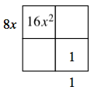
- 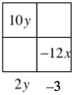

CL 3-116. For each equation below, solve for x.

- 2x − 5(x + 4) = −2(x + 3)

- (x − 1)(x + 7) = (x + 1)(x − 3)

CL 3-117. For each equation below, solve for y.

  - 6x − 2y = 4
- 3y = 4x − 2y + 10

CL 3-118. Simplify each expression.

- (5x³)²
- 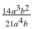
- 2m³n²· 3mn⁴

