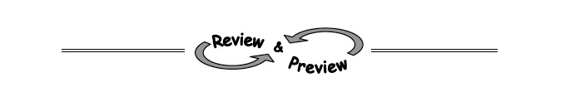
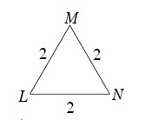
- 5-36. Which of the triangles below are similar to ∆LMN at right? How do you know? Explain. Hints⇔Help
  - 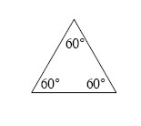b.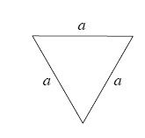
c.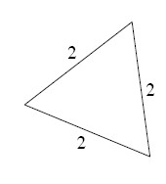d.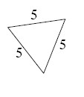
5-37. Find the equation of the line that has a 33.7° slope angle and a y-intercept at (0, 7). Assume the line has a positive slope. Hints⇔Help
5-38. For each triangle below, write a trigonometric equation relating a, b, and θ. Hints⇔Help
a.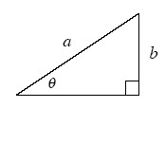b.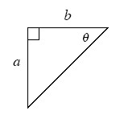c.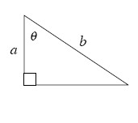
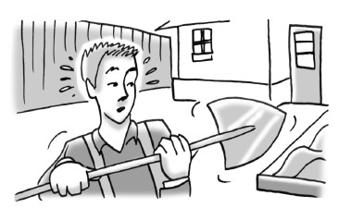
- 5-39. Kendrick is frantic. He remembers that several years ago he buried his Amazing Electron Ring in his little sister’s sandbox, but he cannot remember where. A few minutes ago he heard that someone is willing to pay $1000 for it. He has his shovel and is ready to dig. Hints⇔Help
  - The sandbox is rectangular, measuring 4 feet by 5 feet, as shown below. If Kendrick only has time to search in the 2 foot-square shaded region, what is the probability that he will find the ring?
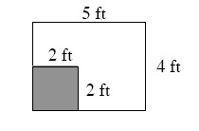
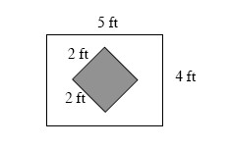
  - What is the probability that he will not find the ring? Explain how you found your answer.
  - Kendrick decides instead to dig in the square region shaded at right. Does this improve his chances for finding the ring? Why or why not?

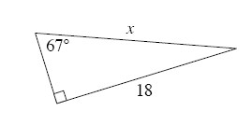
- 5-40. Estelle is trying to find x in the triangle at right. She lost her scientific calculator, but luckily her teacher told her that sin 23° ≈ 0.391, cos 23° ≈ 0.921, and tan 23° ≈ 0.424. Hints⇔Help
  - Write an equation that Estelle could use to solve for x.
  - Without a calculator, how could Estelle find sin 67°? Explain.

