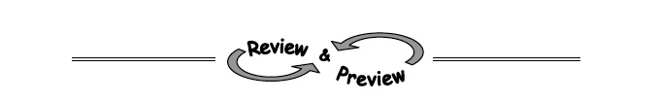
5-46. For each triangle below, use your triangle shortcuts from this lesson to find the missing side lengths. Then find the area and perimeter of the triangle.
  - 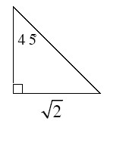 b. 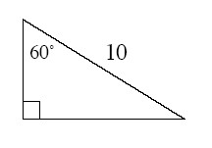
5-47. Use the relationships found in each of the diagrams below to solve for x and y. Assume the diagrams are not drawn to scale. State which geometric relationships you used.
a.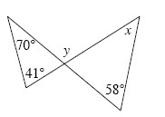 b.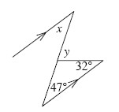
c.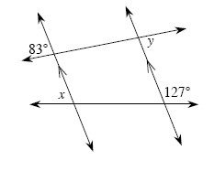d.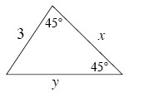
5-48. On graph paper, graph if A(1, 6) and B(5, 2).
- Find AB (the length of ). Leave your answer in exact form. That is, do not approximate with a decimal. Explain your method.

- Reflect across the y-axis to create . What type of shape is ABB′A′ if the points are connected in order? Then find the area of ABB′A′.
5-50. Decide if each pair of triangles below are similar. If they are similar, show a flowchart that organizes your reasoning. If they are not similar, explain how you know.
a.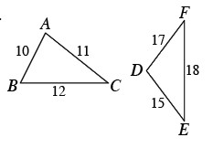 b.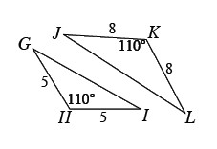
c.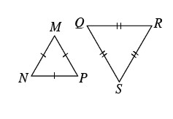d.