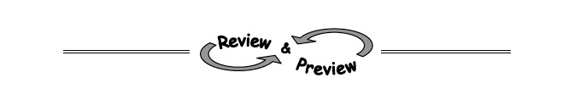
5-56. The sides of each of the triangles below can be found using one of the shortcuts from Section 5.2. Try to find the missing lengths using your patterns. Do not use a calculator.
a.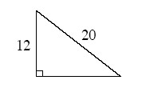b. 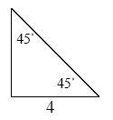c.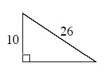d. 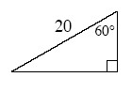
5-57. Copy the diagram below onto your paper.
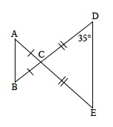
- Find the measures of all the angles in the diagram.

- Make a flowchart showing that the triangles are similar.

- Cheri and Roberta noticed their similarity statements for part (b) were not the same. Cheri had stated ΔABC ∼ ΔDEC , while Roberta maintained that ΔABC ∼ ΔEDC . Who is correct? Or are they both correct? Explain your reasoning.
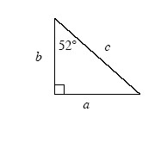
5-58. Using the triangle at right, write an expression representing cos 52° . Then write an expression for tan 52° and cos 38°.

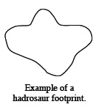

5-59. Hadrosaurs, a family of duck-billed, plant-eating dinosaurs, were large creatures with thick, strong tails. It has recently been determined that hadrosaurs probably originated in North America.
Scientists in Alaska recently found a hadrosaur footprint like the one at right that measured 14 inches across. It is believed that the footprint was created by a young dinosaur that was approximately 27 feet long. Adult hadrosaurs have been known to be 40 feet long. How wide would you expect a footprint of an adult hadrosaur to be? Show your reasoning.

5-60. Jeynysha has a Shape Bucket with a trapezoid, right triangle, scalene triangle, parallelogram, square, rhombus, pentagon, and kite. If she reaches in the bucket and randomly selects a shape, find:
- P(at least one pair of parallel sides)
- P(hexagon)
- P(not a triangle)
- P(has at least 3 sides)

