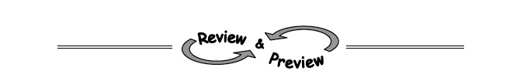
5-67. To paint a house, Travis leans a ladder against the wall. If the ladder is 16 feet long and it makes contact with the house 14 feet above ground, what angle does the ladder make with the ground? Draw a diagram of this situation and show all work.

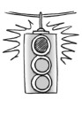

5-68. WACKY DIAGRAMS
After drawing some diagrams on his paper, Jason thinks there is something wrong. Examine each diagram below and decide whether or not the triangle could exist. If it cannot exist, explain why not.
- 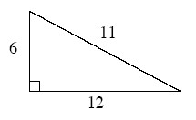b.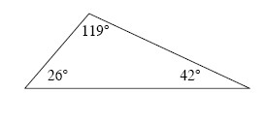
5-69. William thinks that the hypotenuse must be the longest side of a right triangle, but Chad does not agree. Who is correct? Support your answer with an explanation and a counterexample, if possible.

5-70. Plot ΔABC on graph paper with points A(3, 3), B(1, 1), and C(6, 1).
  - Reflect ΔABC across the x-axis. Then translate the result to the left 6 and down 3. Name the coordinates of the result.
  - Rotate ΔABC 90° counterclockwise () about the origin. Then reflect the result across the y-axis. Name the coordinates of the result.
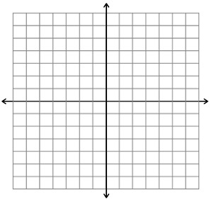
5-71. Solve the equations below, if possible. If there is no solution, explain why.
- −2(5x − 1) − 3 = −10x

- x² + 8x − 33 = 0

- − 12 = 180
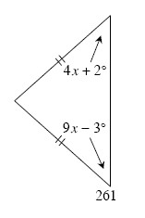
5-72. Multiple Choice: Based on the relationships provided in the diagram, which of the equations below is correct? Justify your solution.
- 4x + 2° + 9x − 3° = 90°
- 4x + 2° = 9x − 3°
- 4x + 2° + 9x − 3° = 180°
- (4x + 2°)(9x − 3°) = 90°

