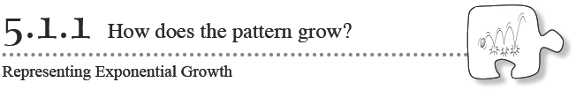
So far in this course, you have been investigating the family of linear functions using multiple representations (especially tables, graphs, and equations). In this chapter, you will learn about a new family of functions and the type of growth it models.
- 5-1. MULTIPLYING LIKE BUNNIES
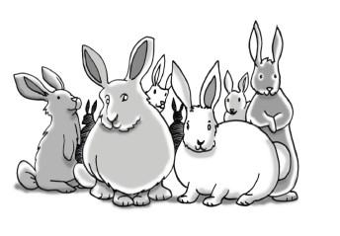
In the book Of Mice and Men by John Steinbeck, two good friends named Lenny and George dream of raising rabbits and living off the land. What if their dream came true?

Suppose Lenny and George started with two rabbits and that in each month following those rabbits have two babies. Also suppose that every month thereafter, each pair of rabbits has two babies.

Your Task: With your team, determine how many rabbits Lenny and George would have after one year (12 months). Represent this situation with a written description of the pattern of growth, a diagram, and a table. What patterns can you find and how do they compare to other patterns that you have investigated previously? Organize your work neatly on another sheet of paper.
What strategies could help us keep track of the total number of rabbits?
What patterns can we see in the growth of the rabbit population?
How can we predict the total number of rabbits after many months have passed?

- 5-3. Lenny and George want to raise as many rabbits as possible, so they have a few options to consider. They could start with a larger number of rabbits, or they could raise a breed of rabbits that reproduces faster. How do you think that each of these options would change the pattern of growth you observed in the previous problem? Which situation might yield the largest rabbit population after one year?
  - To help answer these questions, model each case below with a table for the first five months.
Case 2: Start with 10 rabbits; each pair has 2 babies per month.
Case 3: Start with 2 rabbits; each pair has 4 babies per month.
Case 4: Start with 2 rabbits; each pair has 6 babies per month.
  - Which case would appear to give Lenny and George the most rabbits after one year? How many rabbits would they have in that case?
- 5-4. A NEW FAMILY?
Look back at the tables you created in problems 5-1 and 5-3.
- What pattern do they all have in common? Functions that have this pattern are called exponential functions.

- Using the graph on the next page, graph the data for Case 2. Give a complete written description of the graph.

