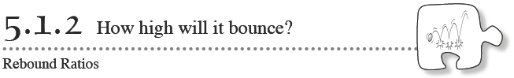
Many games depend on how a ball bounces. For example, if different basketballs rebounded differently, one basketball would bounce differently off of a backboard than another would, and this could cause basketball players to miss their shots. For this reason, manufacturers have to make balls’ bounciness conform to specific standards. In this lesson, you will investigate the relationship between the height from which you drop a ball and the height to which it rebounds.
5-18. Listed below are “bounciness” standards for different kinds of balls
- Tennis balls: Must rebound approximately 111 cm when dropped from 200 cm.

- Soccer balls: Must rebound approximately 120 cm when dropped from 200 cm onto a steel plate.

- Basketballs: Must rebound approximately 53.5 inches when dropped from 72 inches onto a wooden floor.

- Squash balls: Must rebound approximately 29.5 inches when dropped from 100 inches onto a steel plate at 70º
Discuss with your team how you can measure a ball’s bounciness. Which ball listed above is the bounciest? Justify your answer. Justify your answer.

5-19. THE BOUNCING BALL
Your task: With your team, find the rebound ratio for a ball. Your teacher will provide you with a ball and a measuring device. You will be using the same ball again later, so make sure you can identify which ball your team is using. Before you start your experiment, discuss the following questions with your team.

What do we need to measure?
How should we organize our data?
How can we be confident that our data is accurate?

You should choose one person in your team to be the recorder, one to be the ball dropper, and two to be the spotters. When you are confident that you have a good plan, ask your teacher to come to your team and approve your plan.
- Measure at 120 cm, 100 cm, 75 cm, 65 cm, and 40 cm (Students should measure several drop heights, and the intervals between drop heights should not be evenly spaced)
- Measure 3 times at each height
- Use the bottom of the ball as the place where we measure the height
- Record your data in this table:
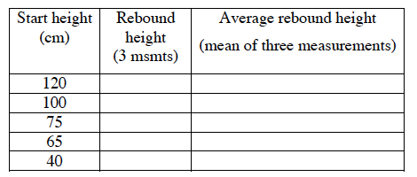
5-20. MODELING YOUR DATA: Work with your team to model the data you collected by considering parts (a) through (c) below
- In problem 5-19, does the height from which the ball is dropped depend on the rebound height, or is it the other way around? With your team, decide which is the independent variable and which is the dependent variable?

- Graph your results on a full sheet of graph paper. Draw a line that best fits your data. Should this line go through the origin? Why or why not? Justify your answer in terms of what the origin represents in the context of this problem.

- Find an equation for your line.

5-21. What is the rebound ratio for your team's ball? How is the rebound ratio reflected in the graph of your line of best fit? Where is it reflected in the rule for your data? Where is it reflected in your table?

*Save your data and your graph in a safe place. You will need them for the next lesson.

