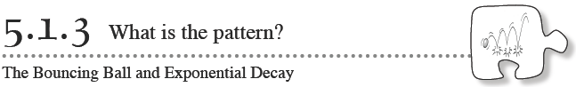
In Lesson 5.1.2, you found that the relationship between the height from which a ball is dropped and its rebound height is determined by a constant multiplier. In this lesson, you will continue this investigation by exploring the mathematical relationship between how many times a ball has bounced and the height of each bounce.
- 5-28. Consider the work you did in Lesson 5.1.2, in which you found a rebound ratio.
  - What was the rebound ratio for the ball your team used?

  - Did the height you dropped the ball from affect this ratio?

  - If you were to use the same ball again and drop it from any height, could you predict its rebound height? Explain how you would do this.

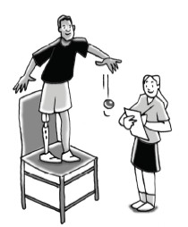
- 5-29. MODEL FOR MANY BOUNCES
Imagine that you drop the ball you used in problem 5-19 from a height of 200 cm, but this time you let it bounce repeatedly.
- As a team, discuss this situation. Then sketch a picture showing what this situation would look like. Your sketch should show a minimum of 6 bounces after you release the ball.

- Predict your ball’s rebound height after each successive bounce if its starting height is 200 cm. Create a table with these predicted heights.

- What are the independent and dependent variables in this situation?

- Graph your predicted rebound heights on a piece of graph paper.
- Should the points on your graph be connected? How can you tell?

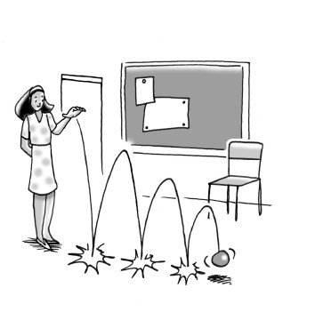
- 5-30. TESTING THE MANY-BOUNCE MODEL
Now you will test the accuracy of the predictions you made in problem 5-29.
Your Task: Test your predictions by collecting experimental data. Use the same team roles as you used in problem 5-19. Drop your ball, starting from an initial height of 200 cm, and record your data in a table. Then compare your experimental data to your predictions using your table and your graph. How do they compare? What might cause your experimental data to be different from your predictions? Do you think that your table and graph model the situation appropriately? Why or why not?
These suggestions will help you gather accurate data:
  - Have a spotter catch the ball just as it reaches the top of its first rebound and have the spotter “freeze" the ball in place.
  - Record the first rebound height and then drop the ball again from that new height.
  - Catch and “freeze" it again at the second rebound height.
  - Repeat this process until you have collected at least six data points (or until the height of the bounce is so small that it is not reasonable to continue).

- 5-31. Compare your graph for the height of successive bounces in problem 5-29 to the graph for drop height versus bounce height that you investigated in Lesson 5.1.2.
  - Can you use the same kind of equation to model the two situations? That is, what family of functions do you think would make the best fit for each data set? Discuss this with your team and write your thoughts below.

  - Describe how the pattern of growth for successive bounces is the same as or different from other models that you have looked at previously.

