6-13. Examine the relationships that exist in the diagram below. Find the measures of angles a , b , c , and d. Remember that you can find the angles in any order, depending on the angle relationships you use.

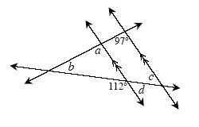
6-14. Examine the triangles below. For each one, solve for x and name which tool you used. Show all work.

- 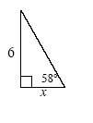
- 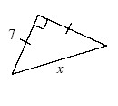

- 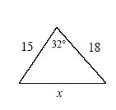

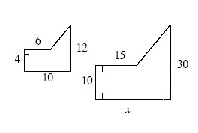
6-15. The two shapes at right are similar.
- Find the value of x. Show all work.
- Find the area of each shape.

6-16. On graph paper, graph ΔABC if A(−2, 7), B(−5, 8), and C(−3, 1).
- Reflect ΔABC across the x -axis to form ΔA′B′C′. Name the coordinates of each new vertex.
- Now rotate ΔA′B′C′ from part (a) 180° about the origin (0, 0) to form ΔA″B″C″. Name the coordinates of each new vertex.
- Describe a single transformation that would change ΔABC to ΔA″B″C″.

6-17. Solve the problem below using any method. Show all work.
Angle A of ΔABC measures 5° more than 3 times the measure of angle B . Angle C measures 20° less than angle B . Find the measure of angles A, B, and C.

6-18. Multiple Choice: Which list of side lengths below could form a triangle?
- 2, 6, 7
- 3, 8, 13
- 9, 4, 2
- 10, 20, 30

