6-24. Use your conjectures about parallel lines and the angles formed with a third line to find the measures of the labeled angles below. Show each step you use and be sure to justify each with an angle conjecture from your Angle Relationships Toolkit. Be sure to write down your reasoning in the order that you find the angles.

- 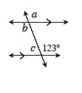
- 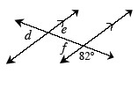
- 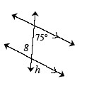

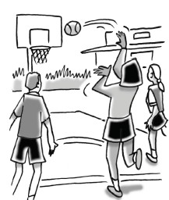
6-25. In a basketball game, a player who gets fouled is awarded a free-throw called a “one-and-one.” When this happens, the player gets a “free shot” from the free-throw line. If the player makes the free-throw, then he or she gets one point and gets to attempt another one-point shot. If the player misses the first free-throw, then no additional attempt is provided.
- If Vicki makes a free-throw 60% of the time, what is the probability that she will score no points? How did you get your answer?
- Is there a greater probability that she will make only one free-throw or two? Create a diagram or chart to show your reasoning .

6-26. Solve the systems of equations below using any method, if possible. Show all work and check your solution. If there is no solution, explain why not.

- y = 2x + 8
3x + 2y = −12
- 2x − 5y = 4
5y − 2x = 10

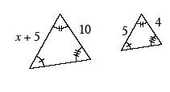
6-27. Examine the triangles at right. Solve for x.

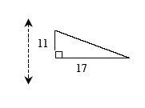
6-28. Examine the triangle and line of reflection at right.
- On your paper, trace the triangle and the line of reflection. Then draw the image of the triangle after it is reflected across the line. Verify your reflection is correct by folding your paper along the line of reflection.
- Find the perimeter of the image. How does it compare with the perimeter of the original figure?
- Find the measure of both acute angles in the original triangle.

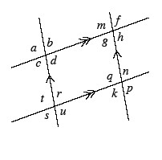
6-29. Multiple Choice: Given the diagram at right, which of the statements below is not necessarily true?
- a = d
- d + r = 180°
- u = n
- t = m
- These all must be true.

