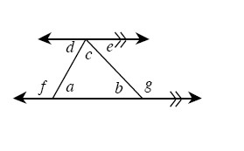
6-35. Copy the diagram at right onto your paper. If a = 53° and g = 125°, find the measures of each labeled angle. Explain how you find each angle, citing definitions and conjectures from your toolkit that support your steps. Remember that you can find the angles in any order, depending on the angle relationships you use.

6-36. On graph paper, graph the line y = + 6 . Name the x and y intercepts.

6-37. As Samone looked at the triangles below, she said, “I think these triangles are congruent.“ Her teammate, Darla, said,” But they don’t look the same. How can you tell?” Samone smiled and said, “Never trust the picture! Look at the angles and the sides. The measures are all the same.”
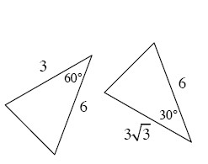
- Solve for the missing side of each triangle. How do they compare?
- Are you convinced that Samone is correct? Explain.

6-38. Write a converse for each conditional statement below. Then, assuming the original statement is true, decide if the converse must be true or not.
- If it rains, then the ground is wet.
- If a polygon is a square, then it is a rectangle.
- If a polygon is a rectangle, then it has four 90° angles.
- If the shape has three angles, it is a triangle.
- If two lines intersect, then vertical angles are congruent.

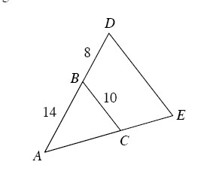

6-39. In the diagram at right, ΔABC ∼ ΔADE.
- Draw each triangle separately on your paper. Be sure to include all measurements in your diagrams.
- Find the length of .

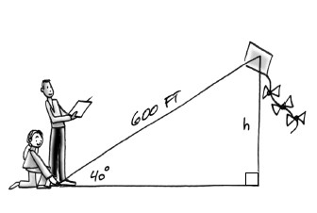

6-40. One measurement used in judging kiteflying competitions is the size of the angle formed by the kite string and the ground. This angle can be used to find the height of the kite. Suppose the length of the string is 600 feet and the angle at which the kite is flying measures 40°. Calculate the height, h , of the kite.

