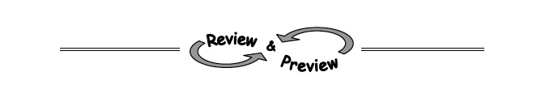
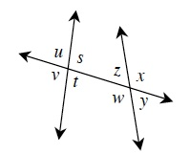
- 6-4. Use the diagram at right to answer the following questions.
  - What type of angle pair isz and t ? That is, what is their geometric relationship?
  - What type of angle pair dos and v form?
  - Name all pairs of corresponding angles in the diagram. Hint: There are four different pairs.
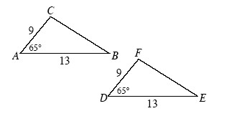
- 6-5. Examine the triangles at right.
  - Are these triangles similar? If so, use a flowchart to show how you know. If they are not similar, explain how you know.
  - Are the triangles congruent? Explain your reasoning .
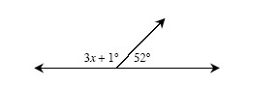
- 6-6. Using the diagram at right, write an equation and find x . Check your answer.
- 6-7. For each of the triangles below, find x.
  - 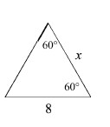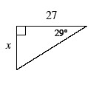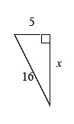
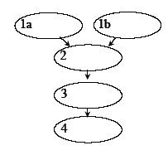
- 6-8. Joey is in charge of selling cupcakes at the basketball games. The game is today at 5:00 p.m. At 3:00 p.m., Joey put some cupcakes into the oven and started working on his homework. He fell asleep and did not wake up until 3:55 p.m. What do you think happened?
Joey knows that the following four statements are facts:
Copy the flowchart at right and decide how to organize the facts into the ovals. You will need to fill in one of the ovals with your own logical conclusion. Be sure that your ovals are in the correct order and that the arrows really show connections between the ovals. What conclusion should your flowchart make?
  - If the cupcakes are burned, then the fans that attend the varsity basketball games will not buy them.
  - If cupcakes are in the oven for more than 50 minutes, they will burn.
  - If the fans do not buy the cupcakes, then the team will not have enough money for new uniforms next year.
  - The cupcakes are in the oven from 3:00 p.m. to 3:55 p.m.
- 6-9. Multiple Choice: ΔABC is defined by points A(3, 2), B(4, 9), and C(6, 7). Which triangle below is the image of ΔABC when it is rotated 90° counter-clockwise () about the origin?
  - A′(−2, 3), B′(−9, 4), C′(−7, 6)
  - A′(−3, 2), B′(−4, 9), C′(−6, 7)
  - A′(−2, 3), B′(−7, 6), C′(−9, 4)
  - A′(2, −3), B′(9, −4), C′(7, −6)
  - None of these

