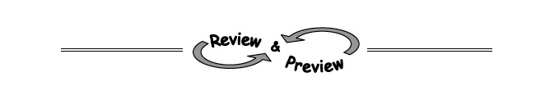
8-6. Write the area of the rectangle at right as a sum and as a product.
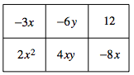

8-7. Multiply the expressions below using a generic rectangle. Then verify that the product of one diagonal equals the product of the other diagonal, like we did in class.
  - (4x − 1)(3x + 5) b. (2x − 7)²

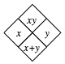8-9. Remember that a Diamond Problem is a pattern for which the product of two numbers is placed on top, while the sum of the same two numbers is placed on bottom. (This pattern is demonstrated in the diamond below.) Complete each Diamond Problem below.
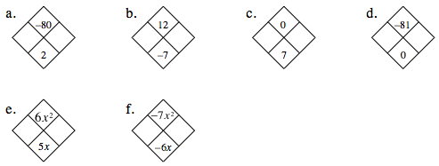

8-11. On graph paper, graph y = x² − 2x − 8.
  - Name the y-intercept. What is the connection between the y-intercept and the rule y = x² − 2x − 8?
  - Name the x-intercepts.
  - Find the lowest point of the graph, called the vertex.
x | y

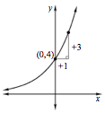
7-62. Use the clues in the graph at right to find a possible corresponding equation in y= ab^{x} form.

