In this lesson you will investigate the characteristics of the family of functions y = b^{x}. As a team, you will generate data for various functions in this family, form questions about your data, and answer each of these questions using multiple representations. Your team will show what you have learned on a stand-alone poster.

- 7-1. BEGINNING TO INVESTIGATE EXPONENTIALS
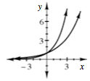
- In Chapter 5, you graphed several exponential functions. Some graphs, like those that modeled the rabbit populations in problem 5-4, were increasing exponential functions and looked similar to the two exponential functions graphed at right.
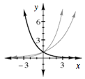
- Other graphs, such as the rebound-height graphs from the bouncing ball activity (problem 5-20), represented decreasing exponential functions and looked similar to the third curve, shown in bold at right.
- You already know that equations of the form y = mx + b represent the family of lines, and you know what effect changing the parameters m and b have on the graph. Today you will begin to learn more about the exponential function family. In their simplest form, the equations of exponential functions look like y = b^{x}.
- By experimenting with different values of b, find three equations in y = b^{x} form that have graphs appearing to match the three graphs shown above. Confirm your results using your graphing calculator and be ready to share your results with the class.

- 7-2. INVESTIGATING y = b^{x} , Part One
What other types of graphs exist for equation of the form y = b^{x} ?
Your Task: With your team, try different values of b to try to find as many different looking graphs as possible. (Stick to small values of b, for example, less than 10. Keep the window on your calculator set from –10 to 10 in both the x and y direction.)
Decide as a team what different values of b to try so that you find as many different looking graphs as possible. Be sure to keep track of what you have tried with a sketch of the resulting graph so that you may refer to it later. Use the questions listed in the “Discussion Points” section below to help get you started.
What special values of b should we consider?
Are there any other values of b we should try?
How many different types of graphs can we find?
How do we know we have found all possible graphs?
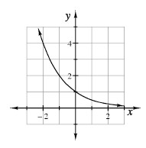
- 7-3. The graph of the function 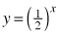 is shown at right.

  - Describe what happens to y as x gets bigger and bigger. For example, what is y when x = 20, x = 100, x = 1000? x = (a much larger number)?
  - Does the graph of have an x-intercept? Explain how you know.
  - When x is very large, the graph of approaches the x-axis. That is, as x gets larger and larger (farther to the right along the curve), the closer the curve gets to the x-axis. In this situation, the x-axis is called an asymptote of . Does have a vertical asymptote? In other words, is there a vertical line that the graph above approaches? Why or why not?

Graphs with Asymptotes
A mathematically clear and complete definition of an asymptote requires some ideas from calculus, but some examples of graphs with asymptotes might help you recognize them when they occur. In the following examples, the dotted lines are the asymptotes, and their equations are given. In the two lower graphs, the y-axis, x = 0, is also an asymptote.
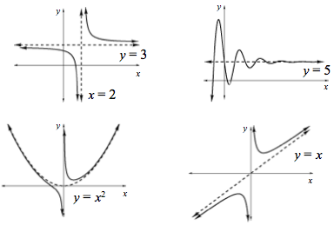
As you can see in the examples above, asymptotes can be diagonal lines or even curves. However, in this course, asymptotes will almost always be horizontal or vertical lines. The graph of a function has a horizontal asymptote if, as you trace along the graph out to the left or right (that is, as you choose x-coordinates farther and farther away from zero, either toward infinity or toward negative infinity), the distance between the graph of the function and the asymptote gets closer to zero.
A graph has a vertical asymptote if, as you choose x-coordinates closer and closer to a certain value, from either the left or right (or both), the y-coordinate gets farther away from zero, either toward infinity or toward negative infinity.

- 7-4. INVESTIGATING y = b^{x} , Part Two
- Now that you, with your class, have found all of the possible graphs for y = b^{x}, your teacher will assign your team one or two of the types of graphs to investigate further. Completely describe the graphs. Use the “Discussion Points” section below to guide your investigation of this graph. Look for ways to justify your summary statements using more than one representation (equation, table, graph).
Write your equations here:
1.
2.
- As a team, organize your graphs and summary statements into a stand-alone poster that clearly communicates what you learned about your set of graphs. Be sure to include all of your observations along with examples to demonstrate them. Anyone should be able to answer the questions below after examining your poster. Use colors, arrows, labels, and other tools to help explain your ideas.
How can you describe the shape of the graph?
What happens when x gets larger? What happens when x gets smaller?
How does changing the value of b change the graph?
Which aspects of the graph do not change?
Are there any special points? Can they be explained with the equation?
Does the graph have any symmetry? If so, where?

