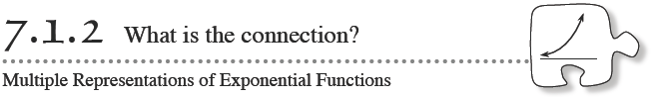
In Chapter 2 you looked at multiple representations (such as a table, graph, equation, or situation) of linear functions. In this chapter you will use multiple representations to learn more about the multiplier and starting point of exponential functions.
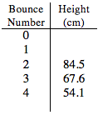
- 7-20. Let’s look at some of the connections between the multiple representations of an exponential function.
  - Arnold dropped a ball during the bouncing ball activity and recorded its height in a table. Part of his table is shown at right. What was the rebound ratio of his ball? At what height did he drop the ball? Write an equation that represents his data. Explain your equation.

  - A major technology company, ExpoGrow, is growing incredibly fast. The latest prospectus (a report on the company) said that so far, the number of employees, y, could be found with the equation y = 3(4)^{x} , where x represents the number of years since the company was founded. How many people founded the company? How can the growth of this company be described?

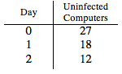
  - A computer virus is affecting the technology center in such a way that each day, a certain portion of virus-free computers is infected. The number of virus-free computers is recorded in the table at right. How many computers are in the technology center? What portion of virus-free computers is infected each day? How many computers will remain virus-free at the end of the third day? Justify your answer.

  - As part of a major scandal, it was discovered that several statements in the prospectus for ExpoGrow in part (b) were false. If the company actually had five founders and doubles in size each year, what equation should it have printed in its report?
- 7-21. Most of the exponential equations you have used in this chapter have been in the form y = ab^{x} .
- What does a represent in this equation? What does b represent?
- How can you identify a by looking at a table? How can you find it in a situation? Give an example for each representation.
- How can you determine b in each representation? Use arrows or colors to add your ideas about b to the examples you created in part (b).

- 7-23. EQUATION → GRAPH
How can you sketch the graph of an exponential function directly from its equation without making a table first? Discuss this with your team. Then make a reasonable sketch of the graph of y = 7(2)^{x} on your paper

