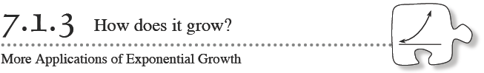
You may have heard the expression, “Money does not grow on trees.” However, money does, in a sense, grow in a savings account. In today’s lesson you will apply your understanding of exponential functions to solve problems involving money and interest. As you work, use the questions below to help focus your team’s discussions. How does it grow?
How does it start? How is it the same (or different)?
How does it grow? What is the multiplier?
How is the rate written as a percent? As a decimal?
7-30. SAVING FOR COLLEGE
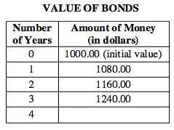
- Suppose you have $1000 to invest and know of two investment options. You can invest in bonds (which pay 8% simple interest) or put your money in a credit union account (which pays 8% compound interest). Will the option you choose make a difference in the amount of money you earn? Examine these two situations below.
Bonds with Simple Interest:
  - If you invest in bonds, your $1000 would grow as shown in the table at right. How does money grow with simple interest?
  - By what percent would your balance have increased at the 4th year? Show how you know.
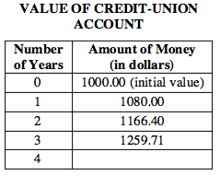
- Accounts with Compound Interest:
  - Instead, if you invest your $1000 in the credit union at 8% compound interest that is compounded once a year, its value would grow as shown in the table at right. Why is there $1166.40 in your account at the second year? Explain how the compound interest is calculated. How is it growing?
  - What will be the balance of the credit-union account at the 4th year? By what percent would this account balance increase at four years? Show how you know.
  - Which type of account – a bond with simple interest or a credit union account with compound interest – grows most quickly?
- 7-31. Assume that the interest is added at the beginning of a new year. Make one graph that shows how each type of investment (simple and compound) starts with $1000 and grows over 8 years. Discuss these questions in your team as you graph:
Can I make the graph clearer with color?
What happens to the money in between the years?
How can I represent the “between” amount on a graph?

7-32. In the previous chapter you used models as an estimate of real behavior. Creating a linear model for scattered data gave you a mathematical way to describe the data and to make predictions.
- Simple and compound interest in problem 7-31 were both step functions. Writing equations for step functions can be very complicated. However, we can model the step functions with other equations we are already familiar with.
- Think about the growth and the starting point for the simple and compound interest situations from this lesson. Model each of the two step functions with an equation. Let y represent the money in the account after x years.
- Check that your equation represents the tables in problem 7-30. If your models do not match the tables, correct your equation.
- Use your model to predict how much your original $1000 investment would be worth at the end of 20 years in the credit union.
- Why are the equations considered a model, instead of a representation of the real behavior? Is there an advantage to using the model to make predictions?

- 7-33. From now on in this course, we will use continuous functions to model situations, unless indicated otherwise.
A third option for investing money is a money market account, which offers 8% annual interest compounded quarterly (four times per year). This means that the 8% is divided into four parts over the year, so the bank pays 2% every three months.
  - Model the value (every three months) of the $1000 investment in this money market account with an equation. Let y represent the money in the account after x quarters.
  - Use the model to find the value of your $1000 investment at four years. How does this compare with your other investment options from problem 7-30?

- 7-34. If you invested $1000 in the credit union from problem 7-30 (interest compounded yearly at 8%), how much would you have at 20 years? If you wanted to earn this same amount of money with bonds with simple interest, what interest rate would the bonds need to earn? Show how you know.

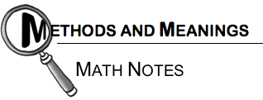

Compound Interest
A bank can pay simple interest in which case the amount in the bank grows linearly. For example, 3% simple interest compounded annually on an initial investment of $2500 would grow in a sequence with a common difference: 0.03(2500) = $75.The equation and table follow:
t(n) = 2500 + 75n
If the bank compounds interest, the relationship is exponential. For example, 3% annual interest, compounded annually, would have a multiplier of 1.03 every year. The equation and table using the example above are:
t(n) = 2500 · 1.03^{n}
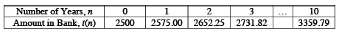
If the bank compounds monthly, the 3% annual interest becomes 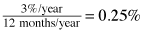 per month, and the multiplier becomes 1.0025. The equation and table for the first ten years follows:
t(m) = 2500 · 1.0025^{m}
