Unit 8 HW Day 1 8-17, 18, 20, 21

Convex and Non-Convex Polygons
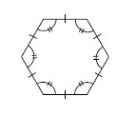
A polygon is defined as a two-dimensional closed figure made up of straight line segments connected end-to-end. These segments may not cross (intersect) at any other points.
A polygon is referred to as a regular polygon if it is equilateral (all sides have the same length) and equiangular (all interior angles have equal measure). For example, the hexagon shown at right is a regular hexagon because all sides have the same length and each interior angle has the same measure.
A polygon is called convex if each pair of interior points can be connected by a segment without leaving the interior of the polygon. See the example of convex and non-convex shapes in problem 8-4.

8-17. The exterior angles of a quadrilateral are labeled a, b, c, and d in the diagram below. Find the measures of a, b, c, and d and then find the sum of the exterior angles.

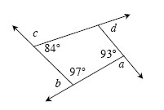

8-18. Find the area and perimeter of the shape below. Show all work.
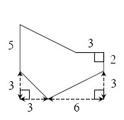

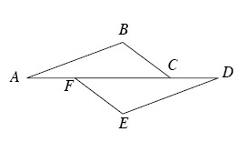
8-20. Suzette started to set up a proof to show that if , and AF =DC , then . Examine her work below. Then complete her missing
statements and reasons. Hints⇔Help
Statement | Reason
1. , and AF =D | 1.
2. mBCF = mEFC and mEDF = mCAB | 2.
3. | 3. Reflexive Property
4. AF + FC = CD + FC | 4. Additive Property of Equality (adding the same amount to both sides of an equation keeps the equation true)
5. AC = DF | 5. Segment addition
6. ΔABC ≅ ΔDEF | 6.
7. | 7. ≅ Δs → parts

8-21. Multiple Choice: Which equation below is not a correct statement based on the information in the diagram?
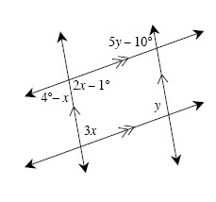
- 3x + y = 180°
- 2x − 1° = 4° − x
- 2x − 1° = 5y − 10°
- 2x − 1° + 3x = 180°
- None of these is correct

