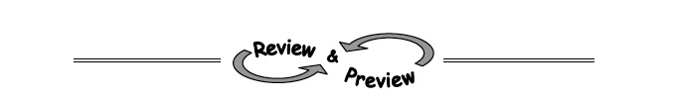
8-17. Use the process you developed in class to factor the following quadratics.
  - x² − 4x – 12 b. 4x² + 4x + 1

c. 2x² − 9x – 5 d. 3x² + 10x − 8

8-18. For each rule represented below, state the x- and y-intercepts, if possible. To what function family do each of the graphs belong?

a. 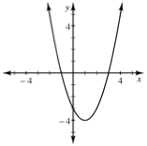 b. 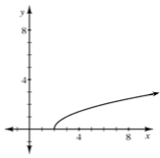

X | −5 | −4 | −3 | −2 | −1 | 0 | 1 | 2
y | 8 | 4 | 0 | −4 | 0 | 2 | 0 | −4
c. 5x − 2y = 40 d.

8-21. Find the point of intersection for each system.
  - y = 2x – 3 b. 3x = y − 2
x + y = 15 6x = 4 − 2y

8-22. Solve each equation below for the given variable, if possible.
a. b. −3(2b − 7) = −3b + 21 − 3b c. 6 − 2(c − 3) = 12

8-23. Find the equation of the line that passes through the points (−800, 200) and (−400, 300).

